John Michael Go
Career Entry Level Java Programming
Date: Jan. 11, 2013

DAY 1

Program Name: Grades

Objective: Program determines if the grade passed or failed.

Algorithm:

- User inputs grade
- Program determines if grade passed or failed

Flowchart:

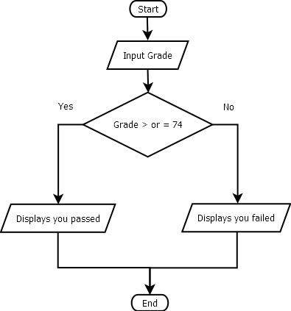

Pseudocode:

import java.util.*;

public class Grade {

public static void main (String[]args){
// variable declaration
Scanner console = new Scanner(System.in);
int grade;
// input grade
System.out.println ("");
System.out.print ("Enter your grade: ");
grade = console.nextInt();
System.out.println ("");
System.out.println ("===============================================================================");
System.out.println ("");
// pass or fail decision
if (grade>=74){
System.out.println ("Congratulations!, you passed!");
} else{
System.out.println ("Sorry you failed!");
}
System.out.println ("");
System.out.println ("");
System.out.println ("");
}

}

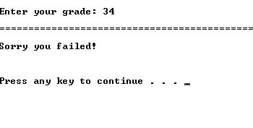
Screenshot:

